Chapter 10 Two sample testing
1. When we test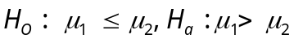at 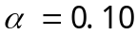, where 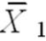 = 77.4, 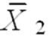 = 72.2, 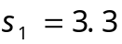, 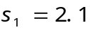, n₁= 6, n₂ = 6, can we reject the null hypothesis? (Assume equal variances)
Solution:
Step 1: Specify the hypothesis
Step 2: Significance Level 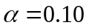
Step 3: Compute t-test statistic, because of the population variances unknown. Then,
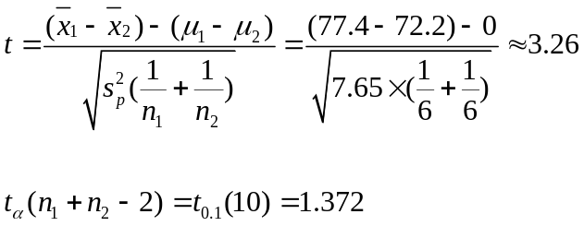
Step 4: The degree of freedom is 10 and thus the critical value is,
Step 5:Conclusion:
Since 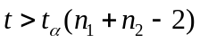, we know t lies in the critical region. Thus, we have enough evidence to reject Ho.
2. Testing the equality of means at 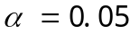, where sample 1 has data: 16, 14, 19, 18, 19, 20, 15, 18, 17, 18; and sample 2 has data: 13, 19, 14, 17, 21, 14, 15, 10, 13, 15, can we reject the null hypothesis? (Assume equal population variances.)
Solution:
We assume that the two data sets are two independent random samples from two normal models with the same(unknown) standard deviation.
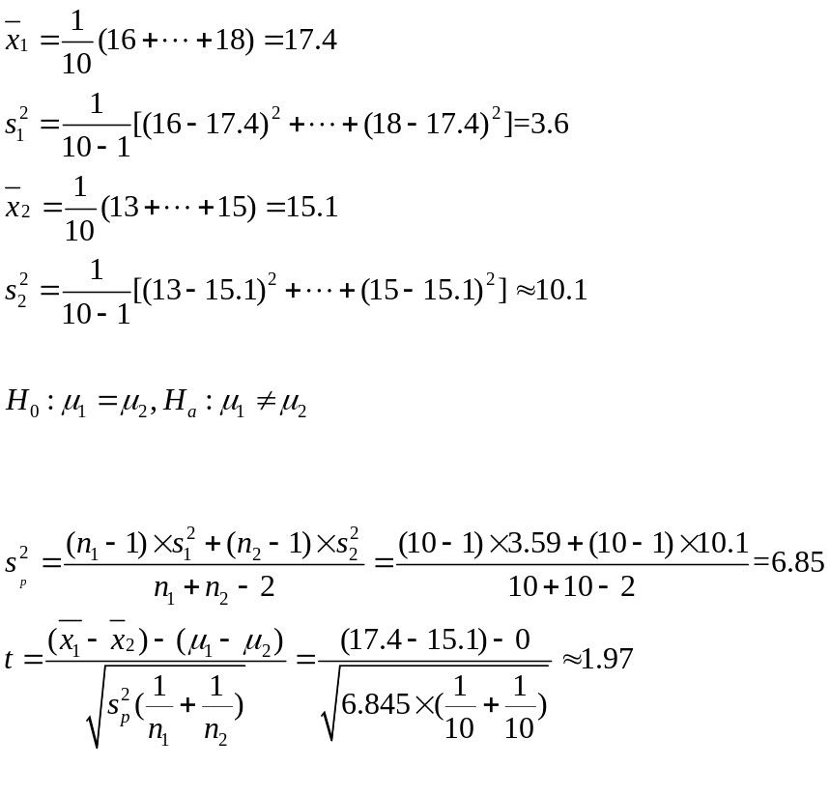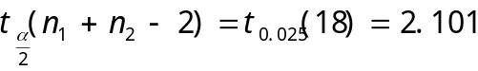
Step 1: Specify the hypothesis

Step 2: Significance Level 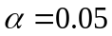
Step 3: Compute t-test statistic, because of the population variances unknown. Then,
Step 4: The degree of freedom is 18 and thus the critical value is,
Step 5:Conclusion:

As 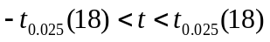, we know t does not lie in the critical region. Thus, we have not enough evidence to reject Ho.
3. A manufacturer claims that the calling range(in miles) of its 900-MHz cordless telephone is greater than that of its leading competitor. You perform a study using 14 randomly selected phones from the manufacturer and 16 randomly selected similar phones from its competitor. The results are shown below. At , is there enough evidence to support the manufacturer`s claim? Assume the populations are normally distributed and population variances are equal.
manufacturer | competitor
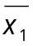=1275 | 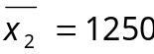
S₁=45 | S₂=30
n₁=14 | n₂=16
Solution:
Step 1: Specify the hypothesis

Step 2: Significance Level
Step 3: Compute t-test statistic, because of the population variances unknown. Then,
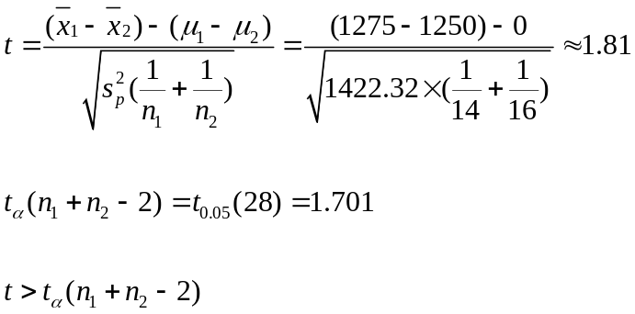
Step 4: The degree of freedom is 28 and thus the critical value is,

Step 5: Conclusion:

Because t is in the reject region, we can conclude there is enough evidence to support the manufacturer`s claim than its phone has greater calling range than its competitor`s.
4. A personnel director claims that the mean annual wage is greater in Allegheny County than it is in Erie County. In Allegheny County, a random sample of 19 residents has a mean annual income of $30.8 and a standard deviation of $8.6. In Erie County, a random sample of 15 residents has a mean annual income of $25.7 and a standard deviation of $5.5. At ,can you support the personnel director`s claim? Assume the population variance are not equal.(unit:$1000)
Step 1: Specify the hypothesis
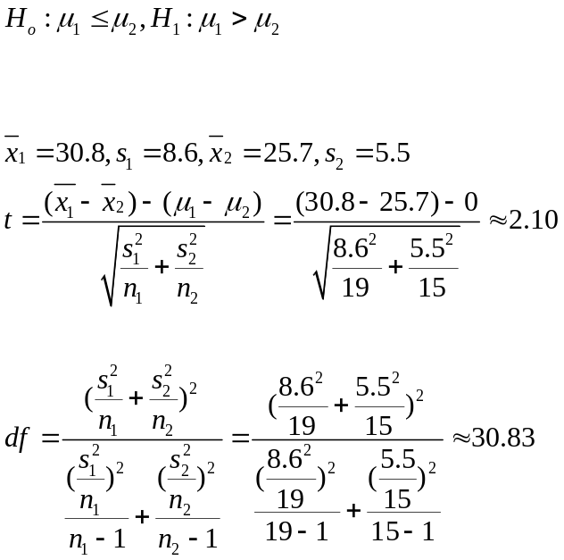
Step 2: Significance Level
Step 3:Compute t-test statistic, because of the population variances unknown. Then,
df=30
Step 4: The degree of freedom is 30,and the critical value is

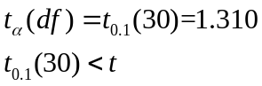
Step 5:Conclusion: Because t is in the reject region, we can conclude that there is enough evidence to support the personnel director`s claim.
5. To test whether a fuel additive improves gas mileage, the gas mileage of nine cars was measured with and without the fuel additive. The results are given below. At , can you conclude that the fuel additive improved gas mileage?
Car | 1 | 2 | 3 | 4 | 5 | 6 | 7 | 8 | 9
gas mileage with additive | 34.5 | 36.7 | 34.4 | 39.8 | 33.6 | 35.4 | 38.4 | 35.3 | 37.9
gas mileage without additive | 36.4 | 38.8 | 36.1 | 40.1 | 34.7 | 38.3 | 40.2 | 37.2 | 38.7
Solution: We employ x_{d} to denote the difference between gas mileage with additive and without additive. Then, we can get a table below.
 | 1 | 2 | 3 | 4 | 5 | 6 | 7 | 8 | 9
x_{d}=x₁-x₂ | -1.9 | -2.1 | -1.7 | -0.3 | -1.1 | -2.9 | -1.8 | -1.9 | -0.8

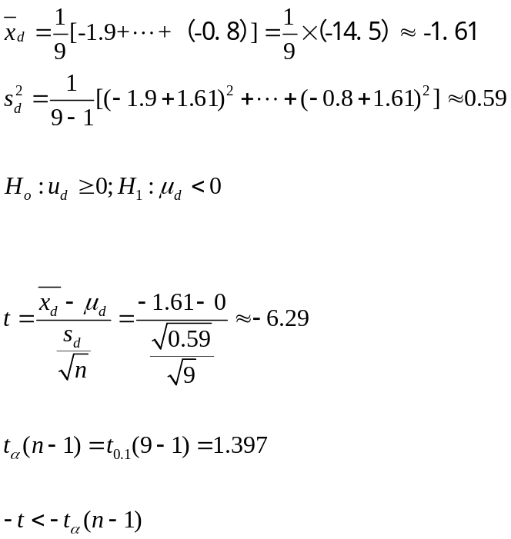
Step 1: Specify the hypothesis
Step 2: Significance Level
Step 3: Compute t-test statistic,
Step 4: The degree of freedom is 8 and the critical value is
Step 5: Conclusion: Because t is in the reject region, we can conclude that there is enough evidence to support the claim that a fuel additive improves gas mileage.

6. A random sample of 8 pairs of identical 12-year-old twins took part in a study to see if vitamins helped their attention spans. For each pair, twin A was given a placebo, and twin B received a special vitamin supplement. A psychologist then determined the length of time (in minute) each remained with a puzzle. The results were
Twin A | 34 | 18 | 39 | 31 | 28 | 26 | 28 | 22
Twin B | 29 | 42 | 33 | 40 | 38 | 40 | 27 | 15

(a).Use a paired t procedure to test the hypothesis at the 0.05 level that the vitamin supplement gives recipients a longer attention span.
(b).Construct 95% confidence interval for the difference in the population means of the attention spans of twins given the placebo and the vitamin supplement.
Solution:
(a). We employ x_{d} to denote the difference between twin A and twin B. Then, we can get a table below.
 | 1 | 2 | 3 | 4 | 5 | 6 | 7 | 8
x_{d}=x₁-x₂ | 5 | -24 | 6 | -9 | -10 | -14 | 1 | 7
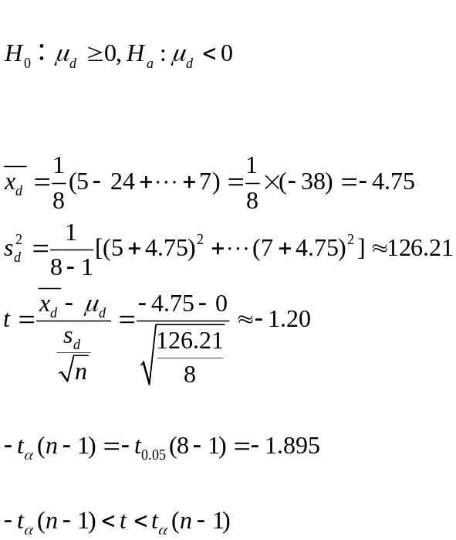
Step 1: Specify the hypothesis
Step 2: Significance Level
Step 3: Compute t-test statistic,

Step 4: The degree of freedom is 7 and the critical value is

Step 5: Conclusion: Because t does not lie in the reject region, we can not conclude that the vitamin supplement gives recipients a longer attention span.
. (b).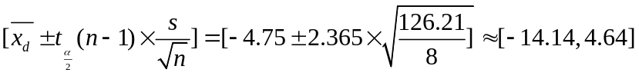
7.A test of driving ability is given to a random sample of 10 student drivers before and after they complete a formal driver education course. Results follow.
Student | Before class | After class
1 | 100 | 136
2 | 121 | 129
3 | 93 | 125
4 | 146 | 150
5 | 101 | 110
6 | 109 | 138
7 | 149 | 136
8 | 130 | 130
9 | 127 | 125
10 | 120 | 129
Test the hypothesis that there is no difference between the before class scores and the after-class scores at
Solution:
We employ x_{d} to denote the difference between twin A and twin B. Then, we can get a table below.
 | 1 | 2 | 3 | 4 | 5 | 6 | 7 | 8 | 9 | 10
x_{d}=x₁-x₂ | -36 | -8 | -32 | -4 | -9 | -29 | 13 | 0 | 2 | -9
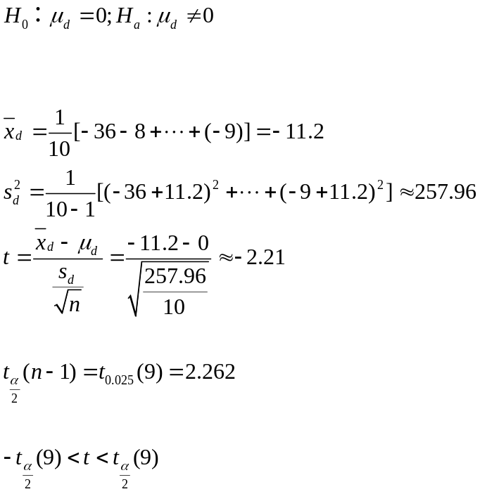
Step 1: Specify the hypothesis

Step 2: Significance Level
Step 3: Compute t-test statistic,

Step 4: The degree of freedom is 9 and the critical value is
Step 5: Conclusion: Because t is not in the reject region, that means there is no difference between the before class scores and the after-class scores

8. A medical research team studied patients using an antidepressant drug to recover from chronic depression. Of 77 patients who used the drug for two years, 5 suffered a new bout of depression. Of 84 patients who used the drug for seven months, 19 suffered a new bout of depression.AT , can you reject the claim that the proportion of patients suffering new bouts of depression are the same for the both groups?
Solution: We employ P₁ to denote the proportion of the patients taking two years drug and P₂ to denote the others taking seven months. Since both and are larger than 5, the proportion is approximately normally distributed.
Step 1: Specify the hypothesis
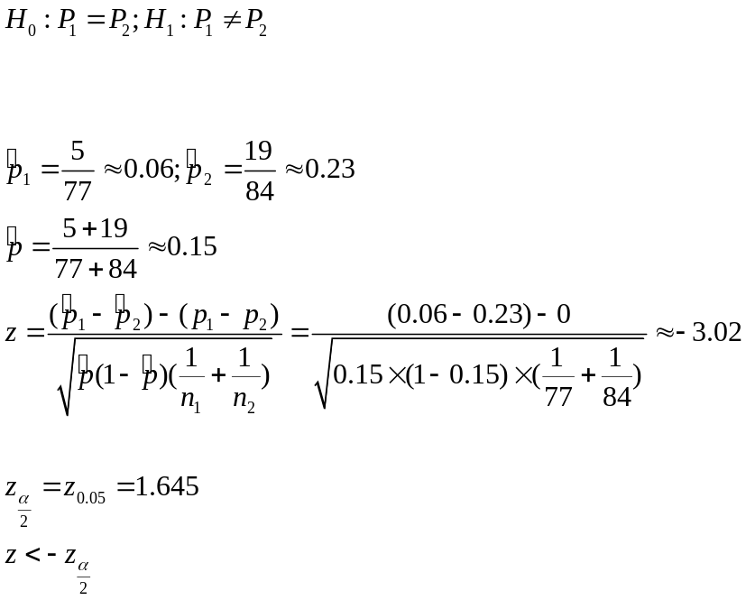
Step 2: Significance Level
Step 3: Compute z-test statistic
Step 4: Use Z-table to find out the critical value ,

Reject Ho
Step 5: Conclusion: Because z lies in the reject region, we can conclude that there is enough evidence to support the claim. The groups are different.

9 In a random survey of 1500 adults in California and 1000 adults in Oregon, you find the percent who are smokers are 18.4% and 20.7%, respectively. At , is there enough evidence to conclude that the proportion of adults who are smokers is lower in California than in Oregon?
Solution:
We employ P₁ to denote the proportion of the smokers in California and P₂ to denote smokers in Oregon. Since both and are larger than 5, the proportion is approximately normally distributed.
Step 1: Specify the hypothesis
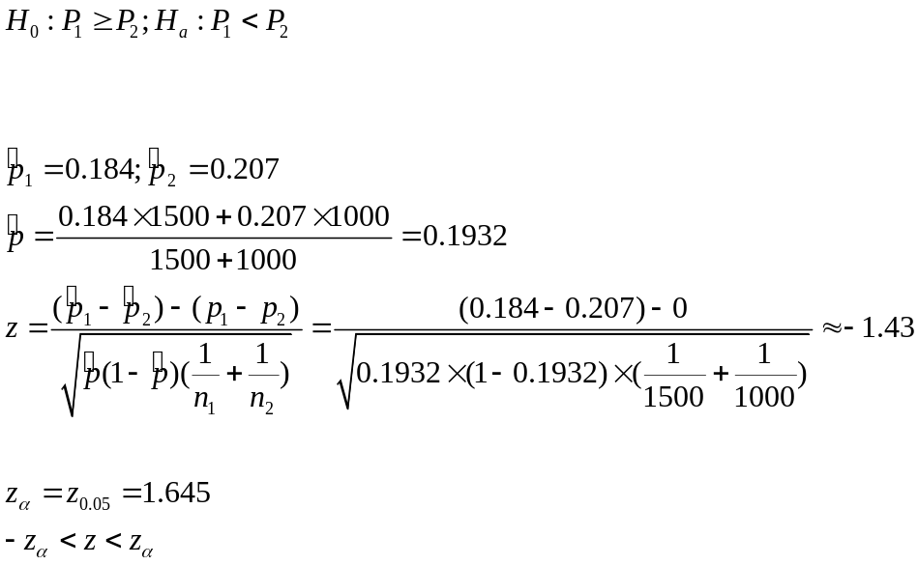
Step 2: Significance Level
Step 3: Compute z-test statistic
Step 4: Use Z-table to find out the critical value,

Step 5: Conclusion: Because z does not lie in the reject region, that means we have not enough evidence to show the proportion of adults who are smokers is lower in California than in Oregon.

No reject
10. Of a random sample of 148 accounting majors, 75 rated a sense of humor as a very important trait to their career performance. This same view was held by 81 of an independent random of 178 finance majors.
a. Test, at the 5% level, the null hypothesis that at least one-half of all finance majors rate a sense of humor as very important.
b. Test, at the 5% level against a two-sided alternative, the null hypothesis that the population proportions of accounting and finance majors who rate a sense of humor as very important are the same.
Solution:
We employ P₁ to denote the proportion of the finance major students who share the idea that humor is important in their career. And P₂ denotes the proportion of the accounting major students holding the same idea. Since both and are larger than 5, the proportion is approximately normally distributed.
(a) Step 1: Specify the hypothesis
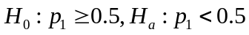
Step 2: Significance Level
Step 3: Compute z-test statistic

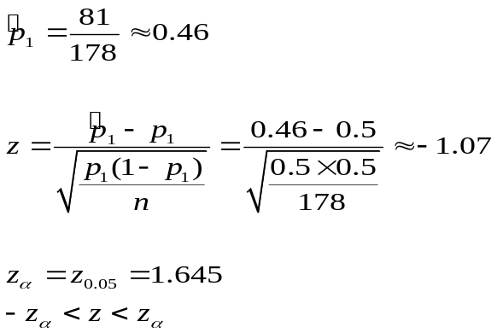
Step 4: Use Z-table to find out the critical value,
Step 5: Conclusion: Because z is not in the reject region, that means we have not enough evidence to show half of finance majors rate a sense of humor are important.

(b)
Step 1: Specify the hypothesis
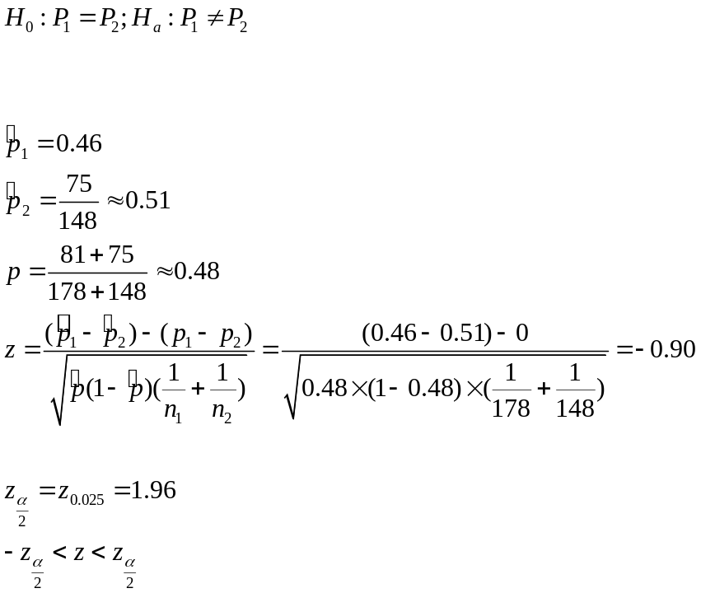
Step 2: Significance Level
Step 3: Compute z-test statistic

Step 4: Use Z-table to find out the critical value,
Step 5: Conclusion: Because z is not in the reject region, that means the population proportions of accounting and finance majors who rate a sense of humor as very important are the same.

